Function Pointer assignments

Mandatory
- WAP to invoke functions below based on user input character using function pointer. Character mapping and respective functions to be invoked are given below.
Character input | Function
+ | int add(int x, int y)
- | int sub(int x, int y)
* | int multiply(int x, int y)
/ | int divide(int x, int y)
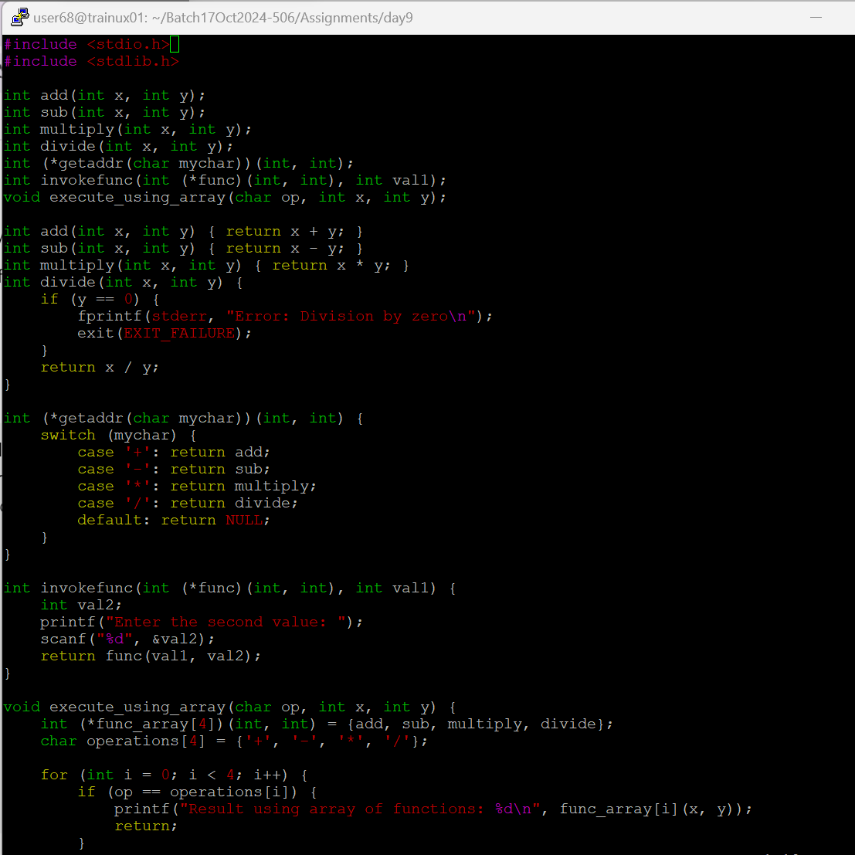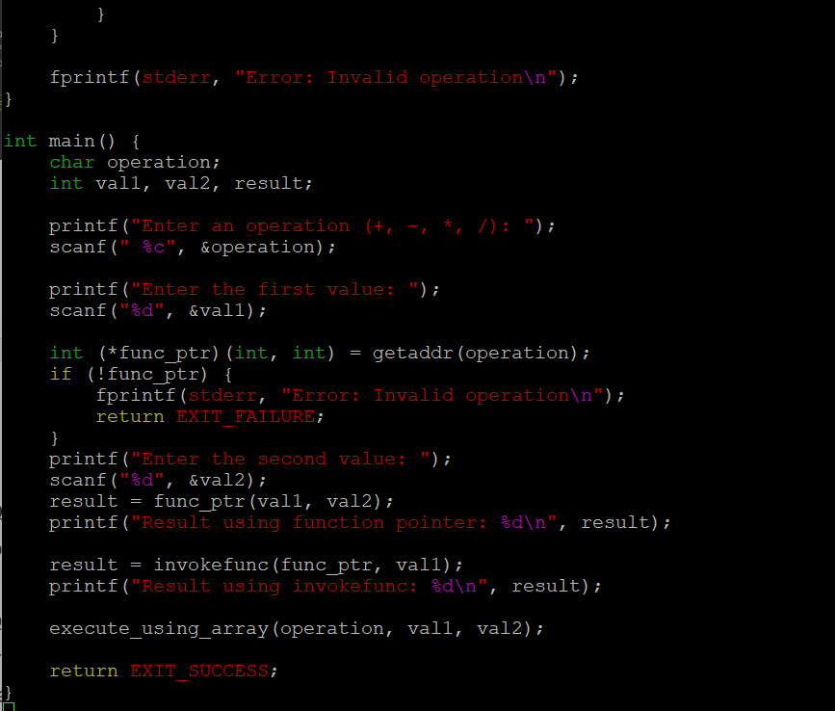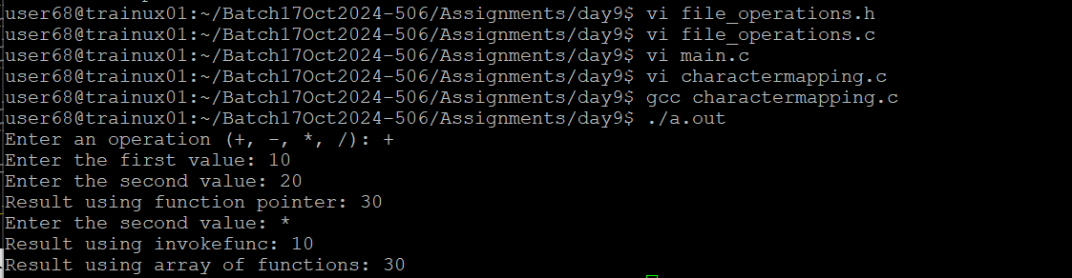
- Extend Q1 to include a function below which will return the address of a function based on input character.
<address of function> getaddr(char mychar);
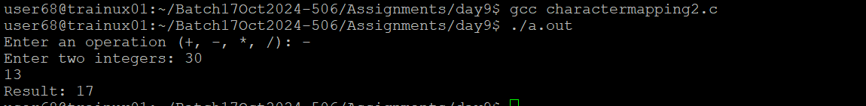
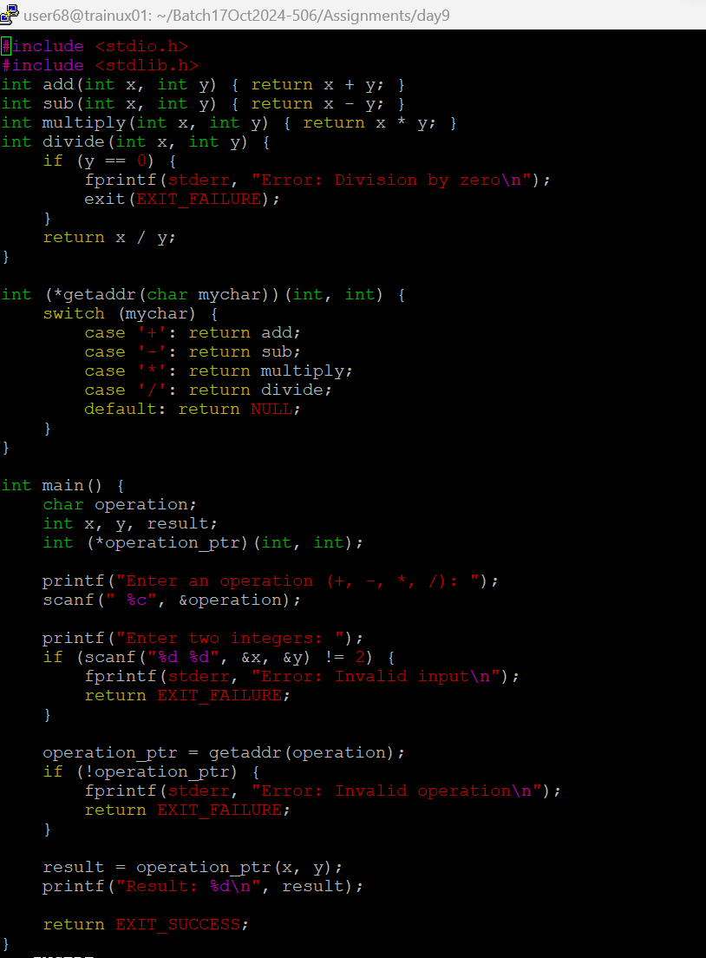
- Extend Q1 to include a function below which takes a function pointer to a calculator function and one integer (value = 10) as arguments and shall invoke the given function with required arguments. For the second argument read input from user. Return the result.
int invokefunc(<function pointer as argument1>, int val1);
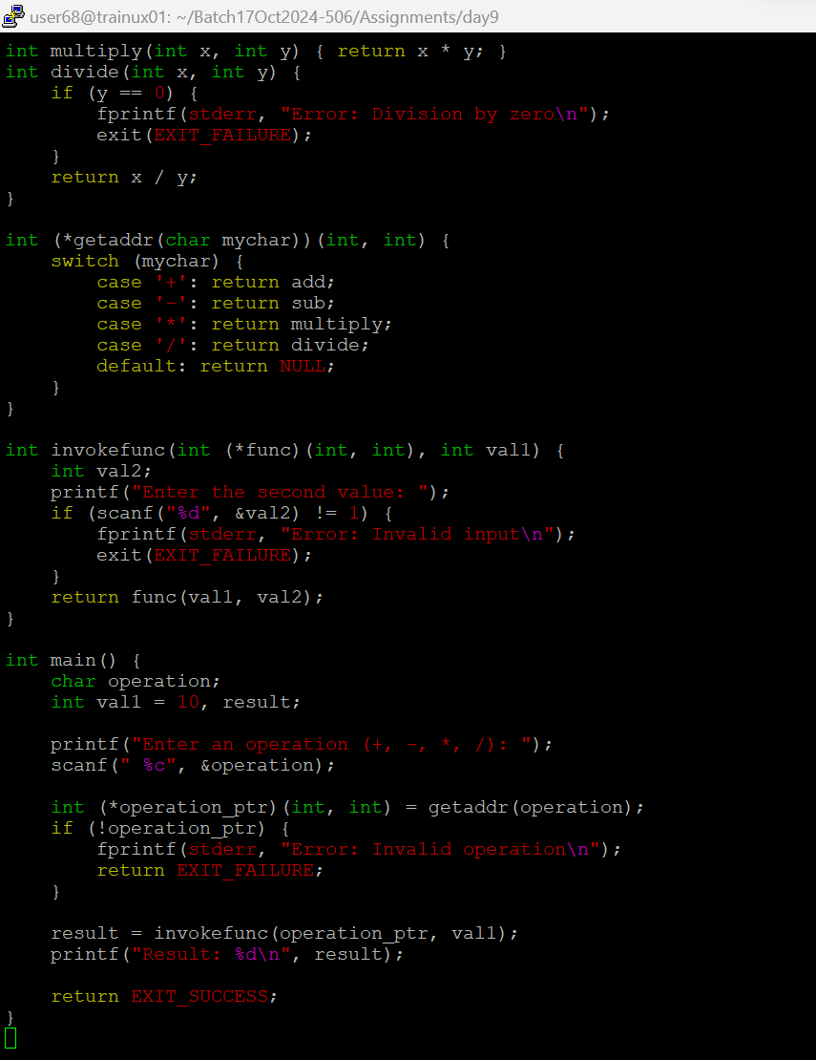
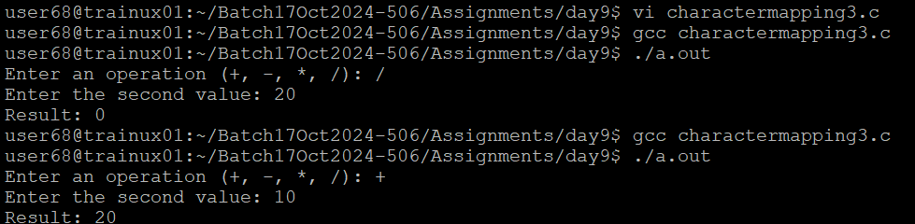
- Extend Q1 to define an array of function pointers and invoke them based user input character.
